EXPERIMENT 1

FLIGHT RESERVATION

Step1: Going to zoho creator and building the app for flight ticket reservation

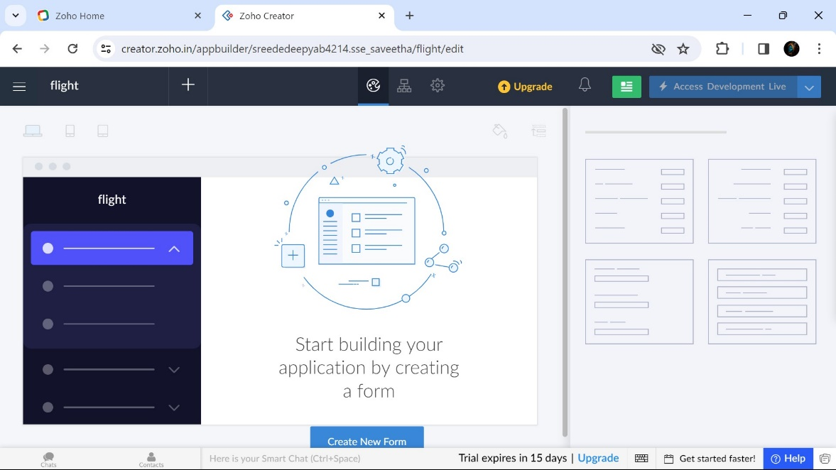

Step 2: Creating a form for Passenger Details

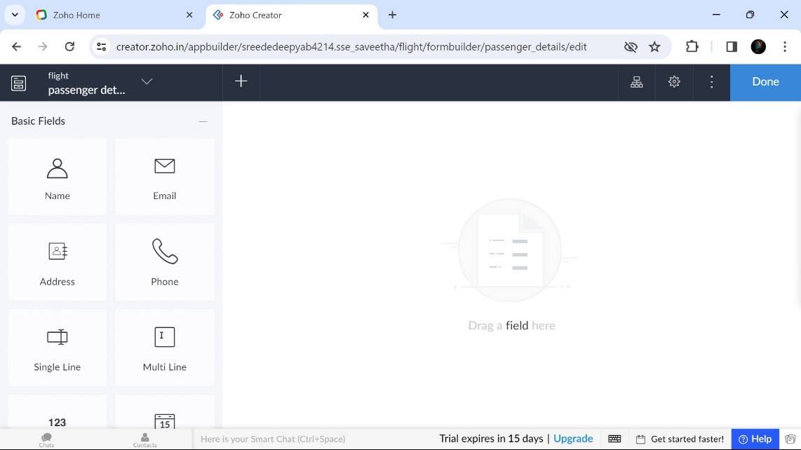

Step 3: Creating a form for Journey Details

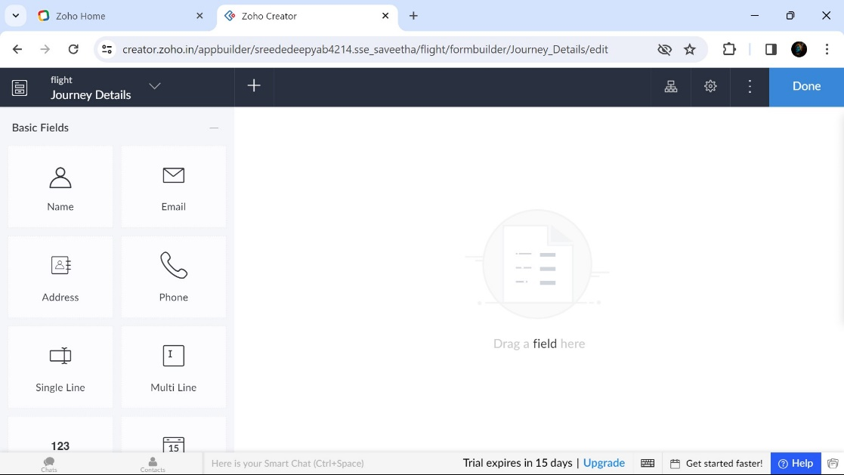

Step 4: Creating a form for Transaction Details

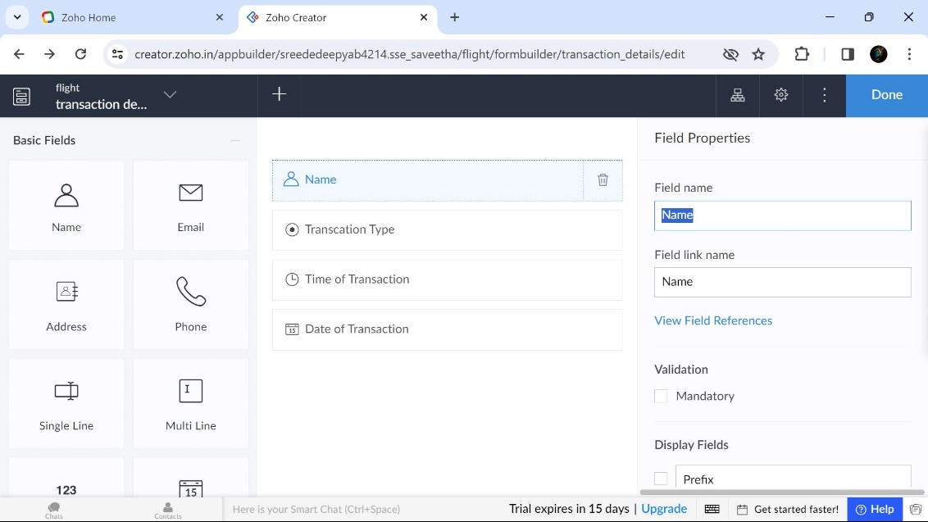

Step 5: displaying all passenger details

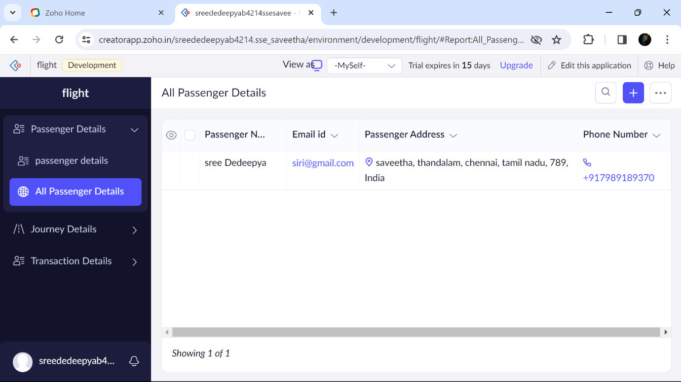

Step 6: Displaying all Journey Details

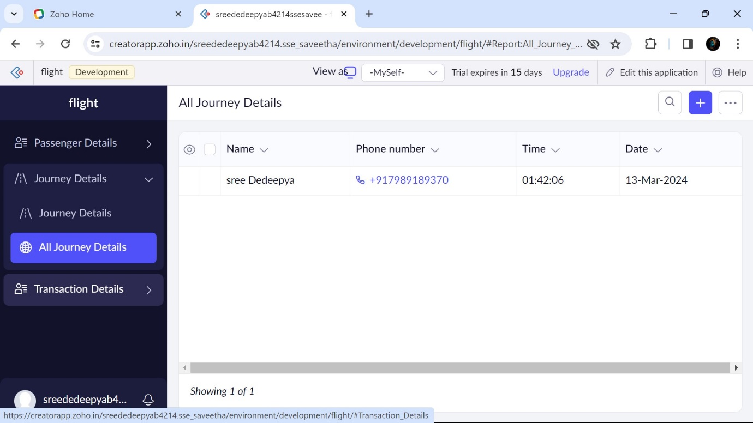

Step 7: Displaying all Transaction details

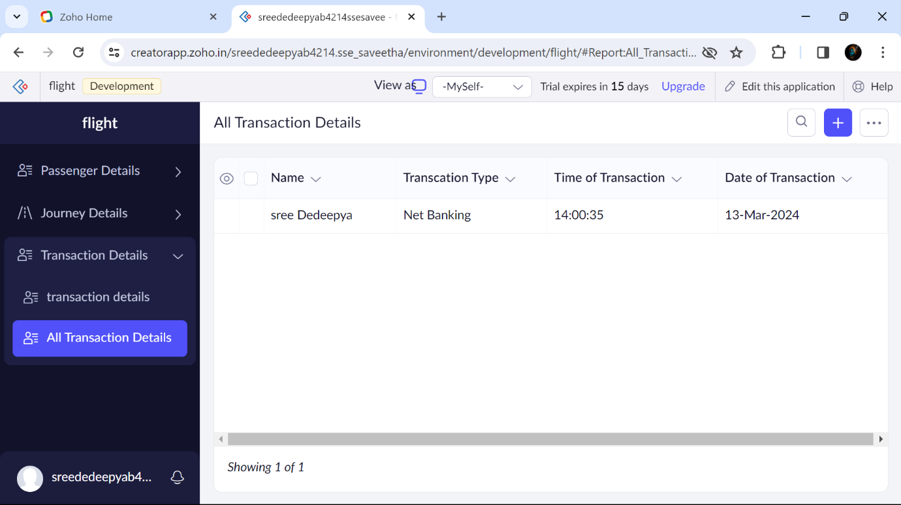

B.SREE DEDEEPYA 192224214